A

Projet Report On

**ScholarSync**

Submitted in partial fulfillment of the requirements For the degree of

**Bachelor of Engineering in Computer Science and Engineering (AI & ML)**

By

# Harshad Bhutal Roll.no 06

# Yash Pal Roll.no 29

# Prajwal Kedari Roll.no 20

Supervisor

# Prof. (Pratiksha Shinde).



Department of Computer Engineering

Innovative Engineers’ and Teachers’ Education society’s

**Bharat College of Engineering**

Badlapur: - 421504

(Affiliated to University of Mumbai)

(2023-24)

## ABSTRACT

Title: Python-Based Note Management, Scoreboard, and Assignment Tracker

In modern educational and professional settings, effective organization and management of notes, scores, assignments, and practical tasks are crucial for success. This abstract introduces a Python-based project aimed at providing a comprehensive solution for these needs.

The project encompasses three main components:

1. Note Management:

This feature allows users to create, organize, and retrieve notes efficiently.

Utilizing Python's file handling capabilities, users can create, edit, and delete notes within a user-friendly interface. Additionally, the system supports categorization and tagging of notes for streamlined access.

2. Scoreboard:

The scoreboard module enables users to track their academic or professional performance over time. Through Python's data manipulation libraries, users can input and update their scores for various assessments, visualize their progress through graphs, and receive insights into areas for improvement.

3. Assignment and Practical Tracker:

Managing assignments and practical tasks is simplified through this module. Users can input assignment deadlines, track completion status, and receive reminders for approaching deadlines. The system also facilitates the organization of practical tasks by allowing users to record progress, notes, and resources associated with each task.

The project leverages Python's versatility and ease of use to provide a flexible and customizable platform for note management, score tracking, and task organization. By integrating these functionalities into a single application, users can enhance their productivity, stay organized, and achieve their academic or professional goals more effectively.

## Contents

**Abstract ...........................................................................................................................................[1]**

**List of Figures .................................................................................................................................[3]**

**List of Tables ....................................................................................................................................[4]**

### 1. Introduction 1 …………………………………………………………………………………...1

1.1 About

1.2 Problem Definition

1.3 Scope of project

1. **Review of Related Work ……………………………………………………………………….3**

1. **Planning ……………………………………………………………………………...................5**

### 4. Methodology ……………………………………………………………………………………6

4.1 Project System & Methodology …………………………………………………. 4.2 System Requirements …………………………………………………………….

4.3 User Requirements………………………………………………………………..

### 5. Design of The System …………………………………………………………………………9

5.1 System Flow Chart…………………………………………………………………….

5.2 Connection & Working………..………………………………………………………

5.3 Code …………………………………………………………………………………..

1. **Experimental Results …………………………………………………………………………16**

1. **Conclusion ……………………………………………………………………………………..17**

**References ......................................................................................................................................18**

### List of Figures

|  |  |  |
| --- | --- | --- |
| **Fig No.** | **Figure Name** | **Page No.** |
| 3 | Work Plan |  |
| 4.1 | Agile Development |  |
| 5.1 | System Flow-chart |  |
| 5.2 | Connection & working |  |
| 5.2.1 | NodeMCU & RFID Connection Code |  |
| 5.2.3 | Spring Boot API |  |
| 6 | Exprimental Result |  |
| 7 | Conclusion & Refrences |  |

### List of Tables

|  |  |  |
| --- | --- | --- |
| **Table No.** | **Table Name** | **Page No.** |
| 2.2.1 | Strength & Weakness of Reviewed App | 4 |
| 2.2.2 | Comparison Amoung Reviewed & Proposed App | 4 |

**1. Introduction:**

#### 1.1 About

Attendance tracking is a fundamental aspect of managing educational institutions, corporate workplaces, and various other organizations. Traditionally, this process has relied on manual methods, such as paper-based sign-in sheets or biometric systems, which often prove to be cumbersome, time-consuming, and prone to inaccuracies. In response to these limitations, Radio-Frequency Identification (RFID) technology has emerged as a transformative solution to automate and enhance attendance management. RFID attendance systems offer a seamless and efficient means of recording and monitoring attendance, providing a more accurate and convenient alternative to traditional methods.

RFID technology utilizes wireless communication and data capture through RFID tags and readers. Each RFID tag, typically attached to an identification card or wearable device, emits a unique identifier when activated by an RFID reader. This technology is adaptable to various environments, from classrooms to boardrooms, and has the potential to revolutionize how organizations manage attendance.In this era of digital transformation, the RFID attendance system not only simplifies the process of taking attendance but also offers valuable insights, analytics, and streamlined administrative tasks. This introduction sets the stage for a comprehensive exploration of RFID attendance systems, delving into their architecture, applications, benefits, and the potential to revolutionize attendance management in a variety of settings.

#### 1.2 Problem Defination

1. Inaccuracy and Fraud: Manual attendance can be easily manipulated or marked on behalf of absent individuals, leading to inaccurate records and potential fraud.
2. Time-Consuming Administrative Tasks: The manual entry of attendance data consumes valuable administrative time and resources, diverting them from more productive activities.
3. Inefficient Resource Allocation: Without real-time data, institutions and organizations struggle to make timely decisions regarding resource allocation and scheduling.
4. Data Integrity and Security: Manual records are susceptible to loss, damage, and unauthorized access, posing risks to data integrity and privacy.
5. Lack of Timely Insights: Traditional methods hinder the ability to generate timely attendance reports and analytics for effective decision-making.
6. Cumbersome Tracking in Large Groups: In large gatherings, events, or lectures,

manual attendance tracking becomes impractical, making it difficult to monitor participants

1.3 Scope of Project:

The scope of the RFID attendance system project encompasses the design, development, and implementation of an efficient and user-friendly system for automating attendance tracking in diverse environments such as educational institutions, corporate offices, and events. The project will involve the selection and deployment of RFID technology, including RFID tags and readers, to accurately record attendance. Key features will include real-time data capture, secure data storage, and reporting capabilities, along with integration into existing attendance management systems where applicable. The project's scope also covers customization to suit specific requirements of different organizations, scalability for future expansion, and the potential for further enhancements and integrations with complementary technologies. Overall, the RFID attendance system project aims to provide a comprehensive solution for optimizing attendance management processes while offering opportunities for adaptability and future improvements.

**2 Review of Related Work:**

#### 2.1 Review on Existing Attendance System

The conventional paper-based attendance system, which many educational institutions and workplaces still rely on, is nothing short of a relic in today's technologically advanced world. It embodies the worst of outdated practices, causing frustration and inefficiencies for both students and employees.

First and foremost, the manual attendance system is plagued by its inherent inaccuracy. The reliance on individuals to mark their attendance on a sheet of paper or sign-in book leaves ample room for dishonesty and manipulation. It's a system that practically encourages proxy attendance, where someone else can easily sign in on your behalf, rendering the records utterly unreliable.

##### 2.1.2 Review on Simple Attendance System

The old-fashioned attendance system is far from compliant with modern data security standards. The lack of real-time data is another glaring issue. In an era where real-time information is vital for decision-making, the manual system falls woefully short. Managers and administrators are left in the dark, unable to make timely adjustments or allocate resources effectively, which can result in scheduling and resource allocation mishaps.

#### 2.2 Critical Remarks

##### 2.2.1 Strength and Weakness

|  |  |  |
| --- | --- | --- |
| **Application** | **Strength** | **Weakness** |
| **Simple Attendance System** | It can’t be hack and edit by another person. | It needs to be preserved carefully. |
| **Existing Attendance System** | Existing attendance system very precise to collect attendance form the user | Since it’s on Digital platform it can be hacked. |

#### Table 2.2.1 Strength and Weakness of Reviewed Attendance System

##### 2.2.2 Application Comparison

|  |  |  |  |
| --- | --- | --- | --- |
| **Application/Criterial** | **Simple Attendance syatem** | **Existing Attendance System** | **Proposed Application**  **(AttenderX)** |
| **User Interface** | Poor | Good | Doesn’t need |
| **Sorting and searching User Data (Information)** | slow | average | Super Fast |
| **Preciseness** | X | √ | √ |
| **Storing Information** | √ | √ | √ |
| **Acessibility** | √ | √ | √ |

Table 2.2.2 Comparison among Reviewed and Proposed Application

**3. Planning:**

The RFID attendance system planning involves a comprehensive process of designing, implementing, and managing an efficient and user-friendly attendance tracking system. It includes the identification of key stakeholders and their requirements, selection of suitable RFID technology components (tags, readers, and software), customization of the system to cater to specific organizational needs, consideration of budget constraints, and a timeline for deployment. Additionally, planning encompasses data security and privacy measures, as well as user training and support strategies to ensure a smooth transition from traditional methods to the RFID-based system. The planning phase should also account for scalability and potential future enhancements, making it a crucial step in the successful integration of RFID technology into attendance management processes.

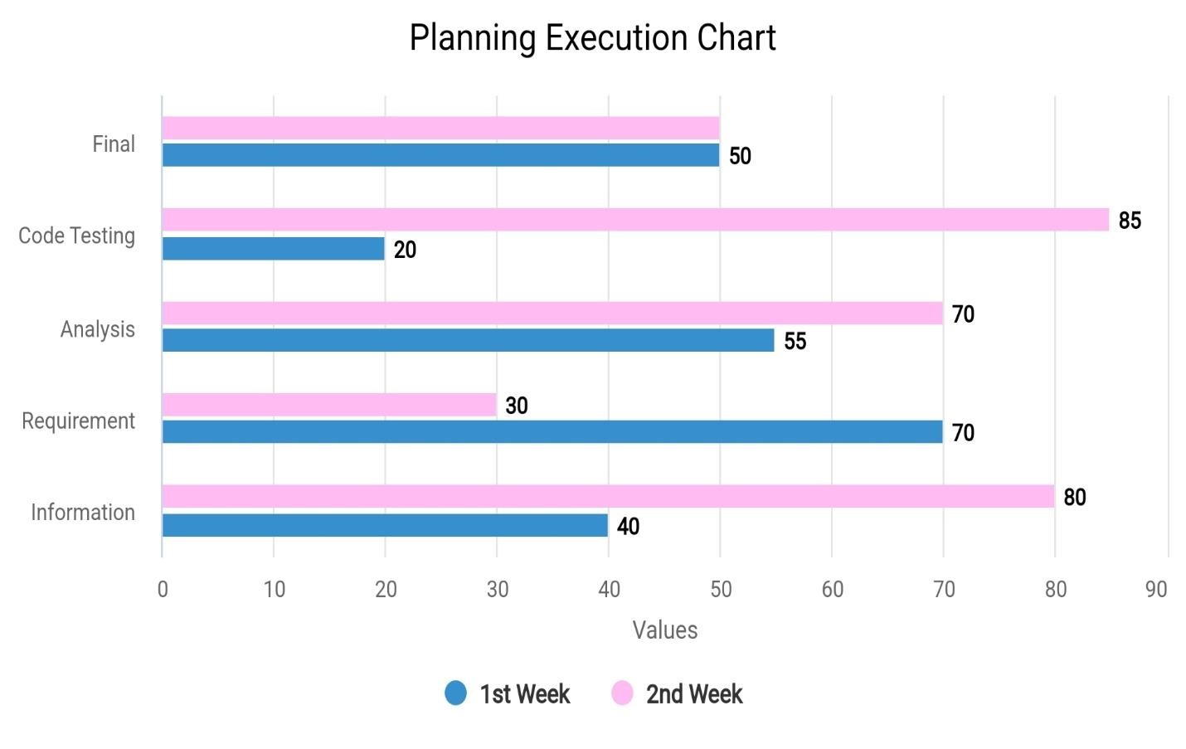

###### Fig.3 Work Plan

The Distribution of project work.

Blue for 1st Week

Pink for 2nd Week

1. **Methodology:** 

4.1 Project System and Methodology

The RFID attendance system methodology entails a structured approach to the system's development and implementation. It involves initial requirements gathering, system design, and component selection, followed by the installation and configuration of RFID hardware and software. The system's functionality is thoroughly tested, and any necessary customizations are made. Once operational, users are trained, and the system undergoes a pilot phase to identify and rectify any issues. Full-scale deployment follows, and ongoing monitoring, maintenance, and support mechanisms are established to ensure the system's long-term effectiveness and efficiency. Regular evaluation and feedback loops are implemented to drive continuous improvements and adaptations as needed, making the methodology a dynamic and iterative process.



Fig.4.1 Spring Boot

##### **4.2 System Requirements**

###### 4.2.1 Software Requirements

1.VScode Studio

2.Spring Boot

3.Java

4.2.2 Hardware Requirements

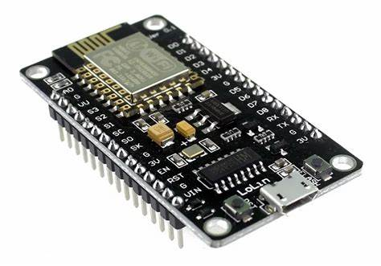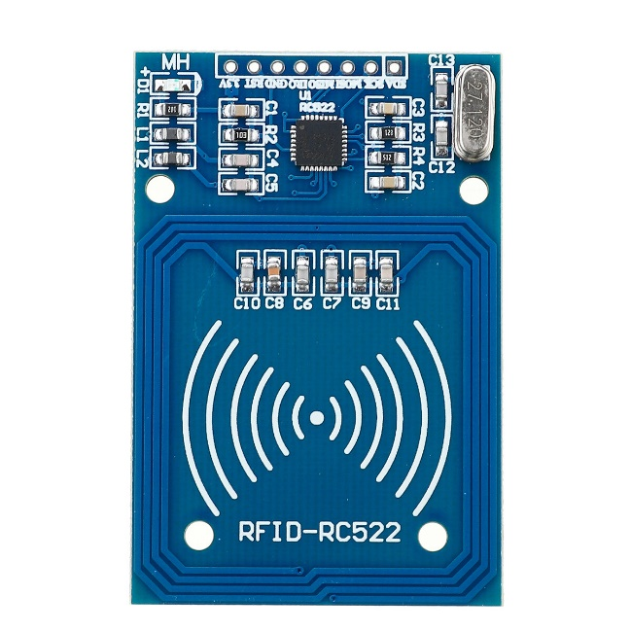

NodeMCU RFID (RC-Reciver)

**4.3 User Requirements**

User requirements for an RFID attendance system include the need for a user-friendly interface that allows quick and efficient RFID tag registration, real-time attendance tracking, and a user authentication process. Users expect secure and accurate data capture, easy integration with existing attendance management systems, and the ability to generate comprehensive attendance reports and analytics. The system should also accommodate various user roles, such as administrators, teachers, and students or employees, with specific access levels and permissions. Additionally, users may require mobile accessibility for convenient on-the-go attendance monitoring, as well as customization options to adapt the system to their specific organizational or institutional needs, ensuring a seamless and user-centric experience.



1. **Design of the System:**

**FLOWCHART**

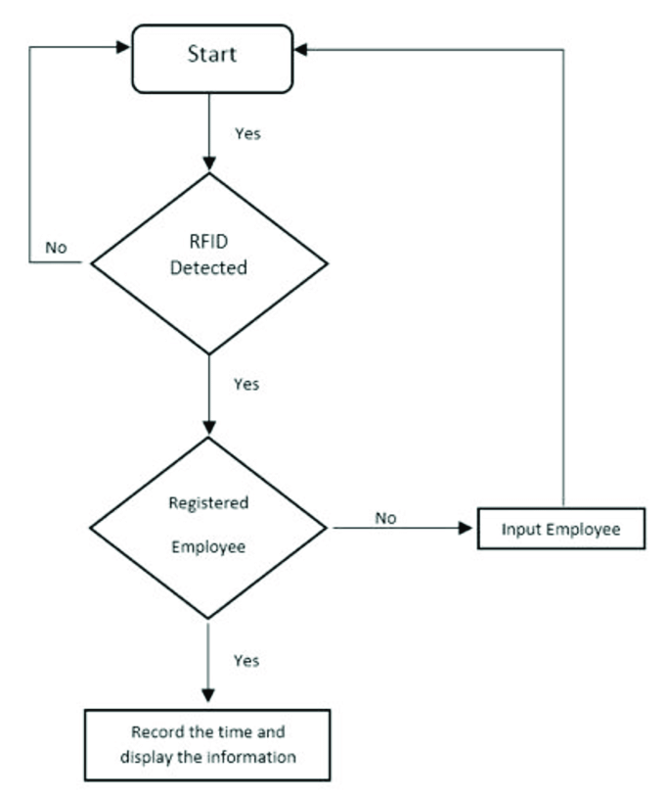

##### **5.2 Connection and Working**

The connection of a NodeMCU (an open-source IoT platform based on the ESP8266 WiFi module) and an RFID (Radio-Frequency Identification) module involves interfacing the RFID module with the NodeMCU using suitable pins. Typically, you would connect the RFID module's power and ground pins to the NodeMCU's 3.3V and GND pins, respectively, to ensure proper power supply. Then, you connect the RFID module's data pins (usually Rx and Tx) to the NodeMCU's GPIO pins, which are designated for serial communication. This allows the NodeMCU to receive RFID tag data and process it for various applications, such as attendance tracking or access control. The NodeMCU can then use its WiFi capabilities to send the RFID tag information to a remote server or perform other IoT-related tasks based on the RFID data received, offering a wireless and connected solution for RFID applications.

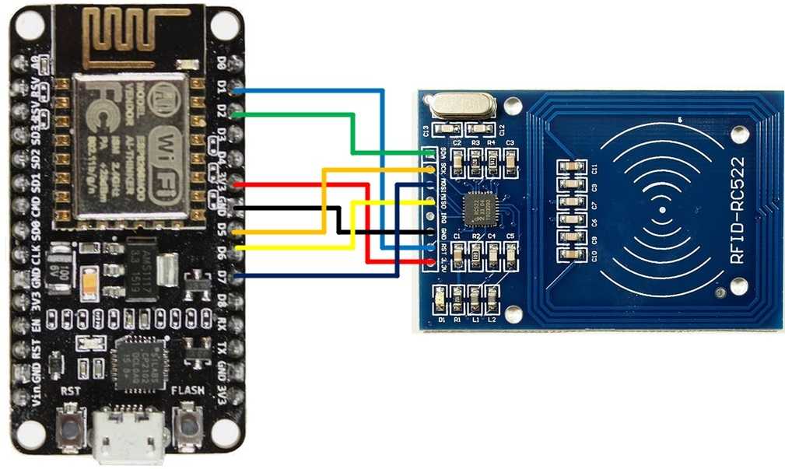

###### Fig.5.2.2



Fig.5.5.3

* Tap the NFC Identity Card on the RFID Reader Device

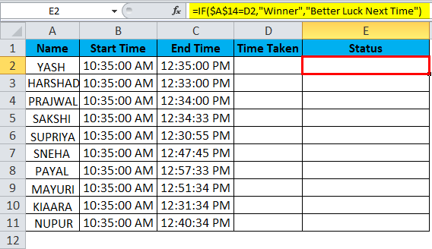

###### Fig.5.2.4

* Once you tap the tag on the device the program execute and the registered ID is get printed on the Excel Sheet

##### **5.2.1 Code**

***Audrino NodeMCU and RFID Reader Connecting Code***

#include <ESP8266WiFi.h>

#include <WiFiClient.h>

#include <ESP8266WebServer.h>

#include <EEPROM.h>

#include <SPI.h>

#include <MFRC522.h>

//#include <ESP8266HTTPClient.h>

#include <ESP8266HTTPClient.h>

#include <ESP8266httpUpdate.h>

#ifndef APSSID

#define APSSID "AttenX"

#define APPSK "12345678"

#define SS_PIN 15

#define RST_PIN 2

#endif

const char * ssid = APSSID;

const char * password = APPSK;

String qpass, qsid;

//RFID Card

int readsuccess;

byte readcard[4];

char str[32] = "";

String StrUID, adrs;

ESP8266WebServer server(80);

WiFiClient client;

MFRC522 mfrc522(SS_PIN, RST_PIN);

void clearErom();

void WifiSetupAttenx();

void handleRoot();

void setup() {

Serial.begin(9600);

pinMode(LED_BUILTIN, OUTPUT);

digitalWrite(LED_BUILTIN, LOW);

Serial.println();

SPI.begin(); //--> Init SPI bus

mfrc522.PCD_Init(); //--> Init MFRC522 card

EEPROM.begin(512);

Serial.print("Configuring access point...");

WifiSetupAttenx();

server.on("/", handleRoot);

server.begin();

Serial.println("HTTP server started");

Serial.println("Please tag a card or keychain to see the UID !");

Serial.println("");

}

void loop() {

server.handleClient();

readsuccess = getid();

if (readsuccess) {

String UIDi=String(String(adrs)+ String(StrUID));

Serial.println(UIDi);

ESPhttpUpdate.update(client, UIDi.c_str());

delay(1000);

}

}

void WifiSetupAttenx() {

WiFi.mode(WIFI_STA);

for (int i = 96; i < 300; ++i) {

adrs += char(EEPROM.read(i));

}

String esid;

for (int i = 0; i < 32; ++i) {

esid += char(EEPROM.read(i));

}

Serial.println();

Serial.print("SSID: ");

Serial.println(esid);

Serial.println("Reading EEPROM pass");

String epass = "";

for (int i = 32; i < 96; ++i) {

epass += char(EEPROM.read(i));

}

Serial.print("PASS: ");

Serial.println(epass);

WiFi.begin(esid.c_str(), epass.c_str());

delay(8000);

if (WiFi.status() == WL_CONNECTED) {

Serial.println("Wifi Connect.......");

Serial.print("IP address: ");

Serial.println(WiFi.localIP());

digitalWrite(LED_BUILTIN, HIGH);

} else {

digitalWrite(LED_BUILTIN, LOW);

Serial.println("Wifi Accesse Point............");

WiFi.mode(WIFI_AP);

WiFi.softAP(ssid, password);

IPAddress myIP = WiFi.softAPIP();

Serial.print("AP IP address: ");

Serial.println(myIP);

}

}

void clearErom() {

for (int i = 0; i < 96; ++i) {

EEPROM.write(i, 0);

}

}

void handleRoot() {

if (server.arg("wifi") != "") {

server.send(200, "text/html", "<h1>You are connected to " + server.arg("wifi") + "</h1>");

// ESPhttpUpdate.update(client, "http://192.168.0.173/LMS/rfid.php?id="+server.arg("wifi"));

WiFi.mode(WIFI_STA);

qsid = server.arg("ssid");

qpass = server.arg("psk");

clearErom();

for (int i = 0; i < qsid.length(); ++i) {

EEPROM.write(i, qsid[i]);

Serial.print("Wrote: ");

Serial.println(qsid[i]);

}

Serial.println("writing eeprom pass:");

for (int i = 0; i < qpass.length(); ++i) {

EEPROM.write(32 + i, qpass[i]);

Serial.print("Wrote: ");

Serial.println(qpass[i]);

}

EEPROM.commit();

// WiFi.begin(qsid, qpass);

WifiSetupAttenx();

} else if (server.arg("api") != "") {

String ads = server.arg("api");

Serial.println("CLEARing EEPROM:");

for (int i = 96; i < 300; ++i) {

EEPROM.write(i, 0);

}

Serial.println("writing eeprom pass:");

for (int i = 0; i < ads.length(); ++i) {

EEPROM.write(96 + i, ads[i]);

Serial.print("Wrote: ");

Serial.println(ads[i]);

}

EEPROM.commit();

server.send(200, "text/html", "<h>AttenX API Set=> " + server.arg("api") + "</h1>");

adrs=ads;

}

else if(server.arg("uapi") != ""){

adrs =server.arg("uapi");

}

else if (server.arg("led") != "") {

if (server.arg("led") == "1") {

digitalWrite(LED_BUILTIN, HIGH);

} else {

digitalWrite(LED_BUILTIN, LOW);

}

} else if (server.arg("ID") != "") {

server.send(200, "text/html", StrUID);

} else if (server.arg("test") != "") {

bool AAb = mfrc522.PCD_PerformSelfTest();

server.send(200, "text/html", (AAb) ? "Connected" : "Disconnect");

} else {

server.send(200, "text/html", "<h>Attenx is ready /n</h1>");

}

}

int getid() {

if (!mfrc522.PICC_IsNewCardPresent()) {

return 0;

}

if (!mfrc522.PICC_ReadCardSerial()) {

return 0;

}

Serial.print("THE UID OF THE SCANNED CARD IS : ");

for (int i = 0; i < 4; i++) {

readcard[i] = mfrc522.uid.uidByte[i]; //storing the UID of the tag in readcard

array_to_string(readcard, 4, str);

StrUID = str;

}

String UIDi=String(String(adrs)+ String(StrUID));

Serial.println(UIDi);

ESPhttpUpdate.update(client, UIDi.c_str());

mfrc522.PICC_HaltA();

return 1;

}

void array_to_string(byte array[], unsigned int len, char buffer[]) {

for (unsigned int i = 0; i < len; i++) {

byte nib1 = (array[i] >> 4) & 0x0F;

byte nib2 = (array[i] >> 0) & 0x0F;

buffer[i * 2 + 0] = nib1 < 0xA ? '0' + nib1 : 'A' + nib1 - 0xA;

buffer[i * 2 + 1] = nib2 < 0xA ? '0' + nib2 : 'A' + nib2 - 0xA;

}

buffer[len * 2] = '\0';

}

**5.2.2 *Device to Excel Sheet Java Code***

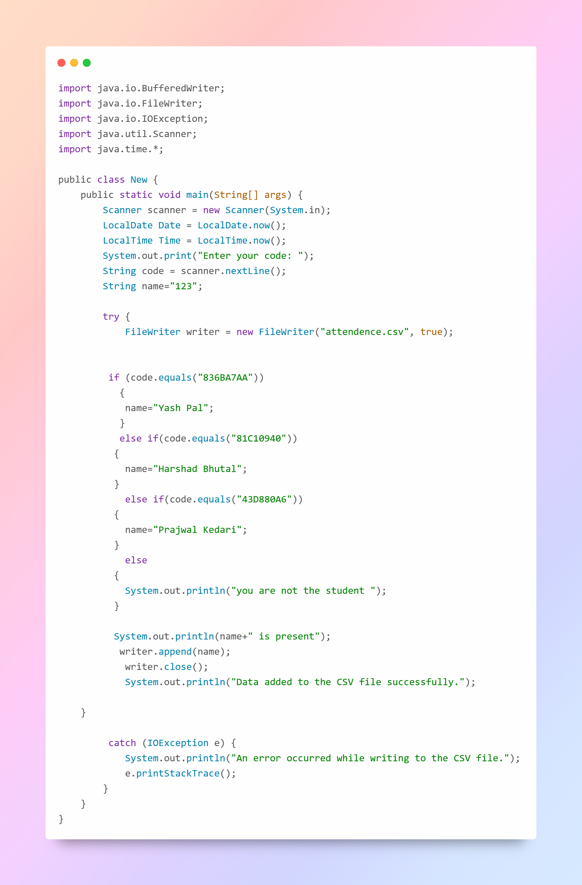

5.2.2

**5.2.3 *Spring Boot API***

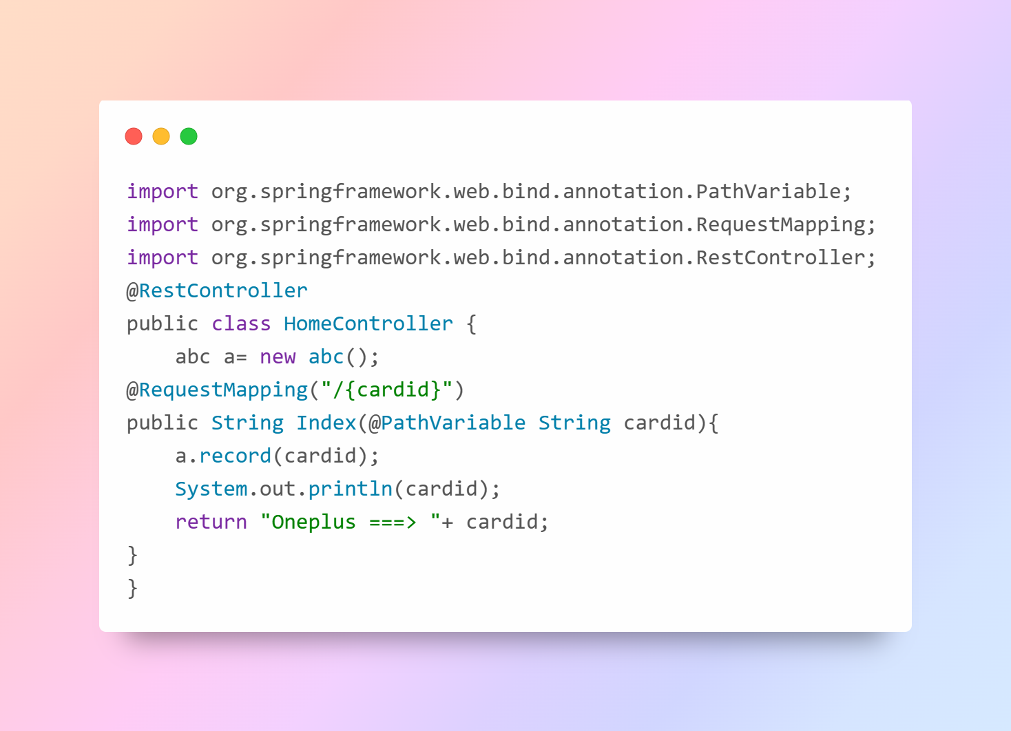

1. **Experimental Results:** 
   * The module was tested . The module performed efficiently with no errors.
   * The Program did not crash at any point in time.
   * Program was able to list all User Data from User’s ID(NFC Tag).
   * While examining the working of the Program, it was found that there is success rate in each direction of the Data Entered.

1. **Conclusion:**

In conclusion, the RFID attendance system represents a significant leap forward in the realm of attendance management, offering an innovative and efficient solution to the challenges posed by traditional manual methods. By harnessing the power of Radio-Frequency Identification technology, this system has demonstrated its capacity to revolutionize how we track and record attendance in various settings, from educational institutions to corporate workplaces and beyond. Its advantages, including real-time data capture, accuracy, and automation, not only streamline administrative tasks but also provide valuable insights for decision-makers. Additionally, the RFID attendance system's adaptability and potential for customization ensure that it can meet the unique needs of diverse organizations. As technology continues to advance, the RFID attendance system stands as a beacon of progress, empowering institutions and businesses to optimize their operations, enhance data security, and improve the overall efficiency of attendance management processes. Its adoption paves the way for a future where attendance tracking is no longer a burden but a seamless, integral part of daily operations.

**References:**

1. Github
2. Arduino
3. Geeksforgeeks
4. Javatpoint
5. W3schools
6. Replit
7. tutorialspoint